Name: Ngoako Prince Pilusa
ST10525635
Table Of Contents
Proposal 1 1
1.Overview of the organisation 1
2.Website goals and objectives: 1
3.Current website Analysis: 1
4.Proposed website features and functionality: 2
5.Design and user experience: 2
6.Technical requirements: 3
7.Timeline and milestones: 3
8.Budget: 4
Proposal 2 4
Organisation Overview 4
Mission and Vision Statements: 4
1. Website Goals and Objectives: 5
2. Current Website Analysis: 5
3. Proposed Website Features 5
4. Layout and Design: 6
5. Technical Requirements Hosting & Domain: 6
6. Programming Languages and Frameworks: 6
7.Timeline and milestones: 7
8.Budget: 7
References: 7
Bibliography 7

Proposal 1

1.Overview of the organisation
Organisation name: We care medical centre
Organisation Type: Private
Brief history/ information:
The We care medical centre was founded in 2014 by Dr Christian Saidiya in Gauteng. The we care medical centre has been well know because of the services offered and being able to accept medical aid or cash. And in later years we care medical aid centre has expanded to limpopo and has been well known in its local regions, but the organisation has little to no online presence apart from the website.
Mission and vision:
The organization’s mission it is to provide high quality, comprehensive health care in a comfortable and modern setting with their team of compassionate and dedicated professionals.
The organization’s vision it is.
Target audience: People / families that generally have health issues and need medical assistance with family medicine, audiology and speech therapy and fertility and more.

2.Website goals and objectives:
- Increase brand visibility and online bookings.
- Make information to be easily discovered about services offered, practitioner, working hours and contact info.

3.Current website Analysis:
Strengths:
It is simple and easily usable by others when wanting to book a consultation or making an appointment. Contact information is also provided and made easy to contact them with a simple click.
Weaknesses:
It has no sign up and login page and most of its information is mashed under one page. The website has an out dated design .

4.Proposed website features and functionality:
The features that will be added are everything will have its own page like the about us, home page on its own, FAQ, services and a login and sign-up page. Re design the website to look more modern.

5.Design and user experience:

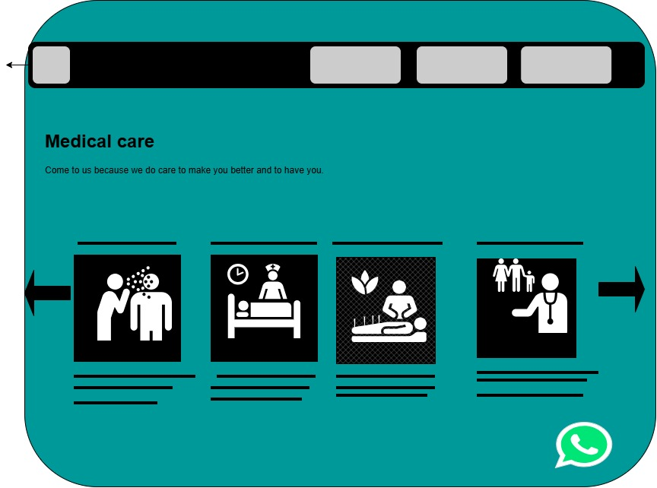
Colour scheme: The colour scheme will be based on the website dark/ deep blue, light blue, red and white (We care medical centre, 2025).
Typography: will be using fonts from sans-serif family because they are clean and modern (Haim I, 2026).
Layout and design: Grid based layout design using card components and modern UI.
User experience:
Looking to create a user-friendly website that is easy to navigate, allowing visitors to locate what they need with low effort.” Clear navigation, organized layouts, and considerate interactions create an engaging experience”. By creating the website with that in mind it will be easily adopted (Intellspot, 2026).

6.Technical requirements:
Domian and hosting: https
Frameworks:
Html, Java scrip and CSS

7.Timeline and milestones:
Week 1
Planning the proposal and how to structure it.
Week 2
Completing and submitting the proposal.
Week 3
Visualizing the design of the website through draw.io.
Week 4
Creating the basic html structure of website of my proposed business.
Week 5
Starting on styling the website using CSS.

8.Budget:
The budget will be estimated around R55000 considering the cost of UI/UX, website planning, website development, responsive optimisation, SEO setup, Domain Renewal, Web hosting, SSL Certificate, Testing, Deployment and maintenance and including annual running cost.

Proposal 2

Organisation Overview
Name: Galito’s(Galito’s Flame-Grilled Chicken)
Brief History: Founded in 1996 in Mbombela (Nelspruit), South Africa, by Louis Germishuys, Galito’s began with a secret family recipe for marinade and flame-grilled piri-piri chicken. Over the years, it has expanded into a global quick-service restaurant (QSR) brand operating across Africa, Asia, Europe, and North America (Anon., 2026).

Mission and Vision Statements:
Mission: To serve delicious, authentic, flame-grilled piri-piri chicken crafted with fresh ingredients at an accessible price. Vision: To be the premier global choice for flame-grilled chicken, known for rich flavour, quality, and exceptional customer experience.
Target Audience: Families and people who are fast food/casual diners seeking high quality, tasteful and healthier meal options.

Website Goals and Objectives:
Create a vibrant, modern digital presence that reflects Galito’s brand identity. Drive foot traffic and online sales via store location and direct delivery/pickup ordering tools. Provide clear information regarding menu offerings, promotions, and franchising opportunities. Key Performance Indicators (KPIs): Traffic Growth: Monthly unique website visits and user sessions. Conversion Rate: Percentage of visitors using the Store Locator or clicking through to place an online order. Engagement: Average session duration and reduced bounce rate on core landing pages. Lead Generation: Number of franchise and business inquiry form submissions.

2. Current Website Analysis:
Strengths:
Strong branding with rich food photography showcasing core products. Clear menu display and easily identifiable store finder links. Mobile-responsive layout adapted for smartphone browsing.
Weaknesses: Navigation can feel segmented depending on regional or promotional banners. Limited interactive elements (e.g., nutrition calculators or customizable order previews). Areas for Improvement: Streamline user journeys directly toward online ordering and nearest store lookup. Enhance site loading speeds and visual accessibility (text contrast, font scalability).
3. Proposed Website Features:
Homepage with high impact visual banner highlighting current the deals, featured meals, and quick links. About Us page with high details about the brand's origins. Filterable menu with spice level indicators, dietary tags, and promotional combos. Store Locator Interactive map with store hours, directions, and direct contact.
Contact Us: Direct customer support contact forms and FAQs. Desired Functionality: Geolocation integration for auto-detecting the nearest outlet. Seamless online ordering/delivery platform integration. Interactive menu filter (e.g., single meals, family feasts, sides, spice scale).
Design and User Experience: Warm, energetic, and rustic aesthetic emphasizing flame-grilled authenticity, African heritage, and fresh ingredients.
Colour Scheme:
Primary: Flame Red and Warm Orange Secondary / Background: Off-White/Cream and Charcoal for crisp text contrast.
Typography:
Headings will be bold with expressive sans-serif font (e.g., Poppins or Montserrat) to convey energy and boldness and body with sans-serif font (e.g., Inter or Open Sans) for maximum legibility on mobile screens.

4. Layout and Design:
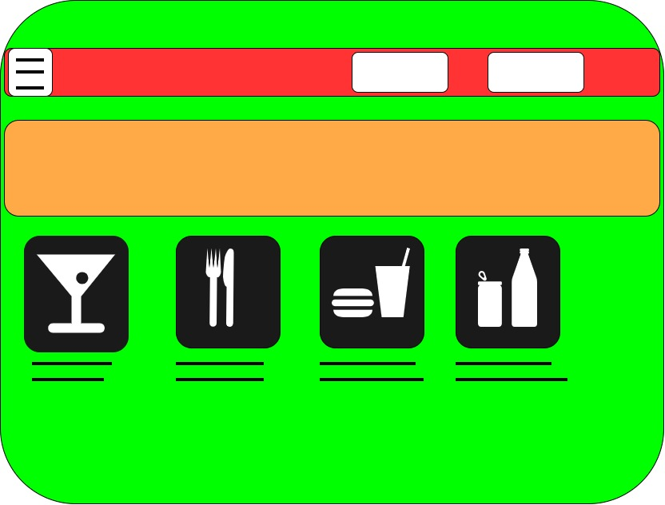
Card-based grid for menu categories and promotions. Sticky header containing key Call to Action buttons like "Find a Store" and "Order Online". User Experience for Mobile devices. Fast page load speeds and intuitive, low effort click navigation pathways.

5. Technical Requirements Hosting & Domain:
I will be using secure, scalable cloud hosting platform like AWS , Azure pr google cloud with SSL certificate.

6. Programming Languages and Frameworks:
Frontend: HTML5, CSS3, JavaScript (or a modern frontend framework like React / Next.js). Backend / CMS: Headless CMS (e.g., WordPress or Strapi) or Node.js for straightforward content and menu management. APIs and Third-Party Integrations: Google Maps API for store locator services. Analytics integration (Google Analytics 4) to track user behavior and KPIs.

7.Timeline and milestones:
Week 1
Planning the proposal and how to structure it.
Week 2
Completing and submitting the proposal.
Week 3
Visualizing the design of the website through draw.io.
Week 4
Creating the basic html structure of website of my proposed business.
Week 5
Starting on styling the website using CSS.

8.Budget:
The budget will be estimated around R45000 considering the cost of UI/UX, website planning, website development, responsive optimisation, SEO setup, Domain Renewal, Web hosting, SSL Certificate, Testing, Deployment and maintenance and including annual running cost.

References:

Bibliography
Anon., 2026. Our Brand story. [Online]
Available at: https://www.nandos.co.za/explore/brand-story
[Accessed 17 August 2026].
Haim I, 2026. 50 Modern Fonts to Use on Your Website in 2026. [Online]
Available at: https://elementor.com/blog/modern-fonts-to-use-on-your-website/
[Accessed 12 August 2026].
Intellspot, 2026. What Makes a Website Intuitive? A Deep Dive into User-Centered Design. [Online]
Available at: https://www.intellspot.com/intuitive-website-design-user-experience/
[Accessed 12 August 2026].
We care medical centre, 2025. We Provide Only the Best Service. [Online]
Available at: https://wecaremedicalcentre.co.za/
[Accessed 11 August 2026].

